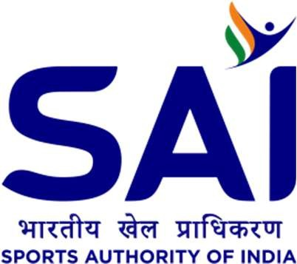

Press Release

Union Sports Minister Anurag Singh Thakur kicks off 1st BIMSTEC Aquatics Championships

New Delhi, Feb 6th: Hon’ble Union Minister for Youth Affairs and Shri Sports Anurag Singh Thakur on Tuesday, February 6th kicked off BIMSTEC Aquatics Championships 2024 which is being held for the first time.

Speaking post the event the honorable Minister said "World's 25% population lives in South Asia and Southeast Asian reason and with the coming together of 7 BIMSTEC countries, the Bay of Bengal area not only becomes a region used for travel and transportation but also becomes an area of progress, development and collaboration which will help in not only deeper friendship but also building a deeper sporting culture which will help deepen even friendship between athletes and that is exactly the thought that our honourable Prime Minister envisioned when he announced this sporting event at the summit in Nepal."

BIMSTEC (The Bay of Bengal Initiative for Multi-Sectoral Technical and Economic Cooperation) constitutes a unique link between South and South-East Asian countries with five members from South Asia (Bangladesh, Bhutan, India, Nepal and Sri Lanka) and two members from South-East Asia (Myanmar & Thailand).

The organisation for the very first time in history is hosting a sports competition which is being hosted in India. The announcement for the same was made by Hon’ble Prime Minister Shri Narendra Modi during the 4th BIMSTEC Summit in 2018, where he announced the organising of the BIMSTEC Youth Water Sports competition in India. The event was initially proposed for the year 2021, however, it was later postponed to 2024 due to the outbreak of the COVID-19 pandemic across the world.

Along with the honourable Union Sports Minister, the opening ceremony was also attended by Minister of Youth Affairs and Sports Nepal Sh. Dig Bahadur Limbu and Sh. Indra Mani Pandey, Secretary General, BIMSTEC High Commissioners & Ambassadors to India of
BIMSTEC among dignitaries from visiting countries and the government of India.

The 1st BIMSTEC Aquatics Championships is being held at Delhi’s Dr. Syama Prasad Mookerjee Swimming Pool Complex from 6th February to 9th February 2024 with competitions being held for Under 20 age category in Swimming, Water Polo and Diving events.

A total of 39 medals will be given out across three sporting events along with a total of 9 trophies that will be at stake. Over 500 personnel are expected at the events, including 268 athletes from various BIMSTEC member countries.

